# Module 2

**Assignment 1 - Create your first S3 bucket. Do the following:**

**1) Upload an object to your bucket.**

**2) Download an object**

**3) Copy your object to a folder**

**4) Delete your objects and bucket**

Below are the steps taken to perform the above-mentioned task.

Go to Console search for S3. As this is global service, we don’t need to select the region.

Step 1: Click on ‘**Create bucket’**.

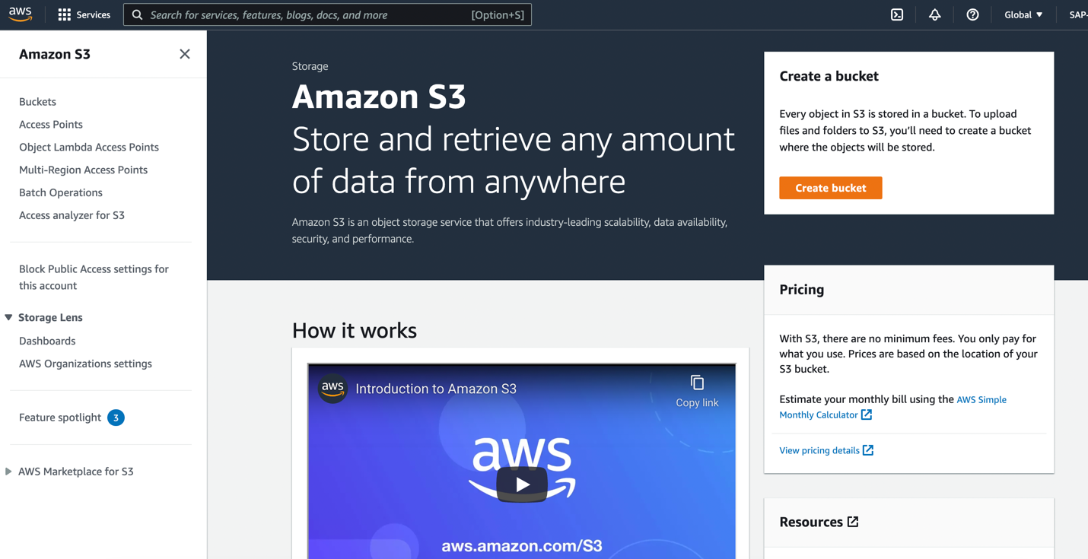

Step 2: Configure below details for bucket creation:

1. General Configuration
   1. **Bucket name**- Give unique name for bucket as given in below image ‘M2A1_bucket’
   2. **AWS Region**- Selected the region for S3 service’s availability zone ‘N. Virginia’.
   3. **Copy settings from existing bucket-** This is optional and can be opt in case if we want to copy the configuration of existing bucket.
2. Object Ownership
   1. **ACLs Disabled/Enabled** – Object ownership and access specification can be defined through this. If ACLs disabled Account owner will be current account and access will be defined with Policies if ACLS enabled, Objects in this bucket will be owned by other accounts and access will be defined with ACLs. By default, this is disabled.

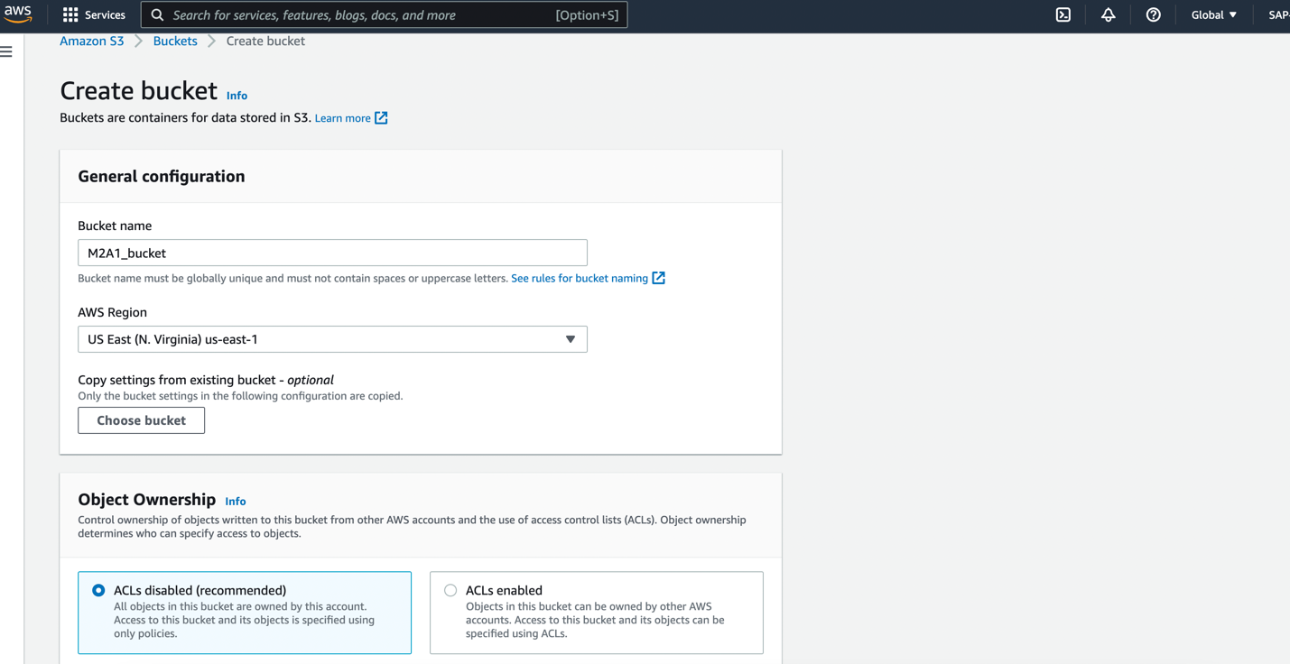

1. Block all public access settings for this bucket– All public access can be blocked with one checked option. Bucket access can be modified with below 4 options. If this option is checked while creating the bucket, bucket will not be accessible publicly.
   * 1. **Block public access to buckets and objects granted through new access control lists (ACLs)**

S3 will block public access permissions applied to newly added buckets or objects, and prevent the creation of new public access ACLs for existing buckets and objects. This setting doesn’t change any existing permissions that allow public access to S3 resources using ACLs.

* + 1. **Block public access to buckets and objects granted through any access control lists (ACLs)**

S3 will ignore all ACLs that grant public access to buckets and objects.

* + 1. **Block public access to buckets and objects granted through new public bucket or access point policies**

S3 will block new bucket and access point policies that grant public access to buckets and objects. This setting doesn't change any existing policies that allow public access to S3 resources.

* + 1. **Block public and cross-account access to buckets and objects through any public bucket or access point policies**

S3 will ignore public and cross-account access for buckets or access points with policies that grant public access to buckets and objects.

To keep the bucket accessible publicly and to uncheck the ‘**Block** *all* **public access**’, tick the acknowledgement checkbox.

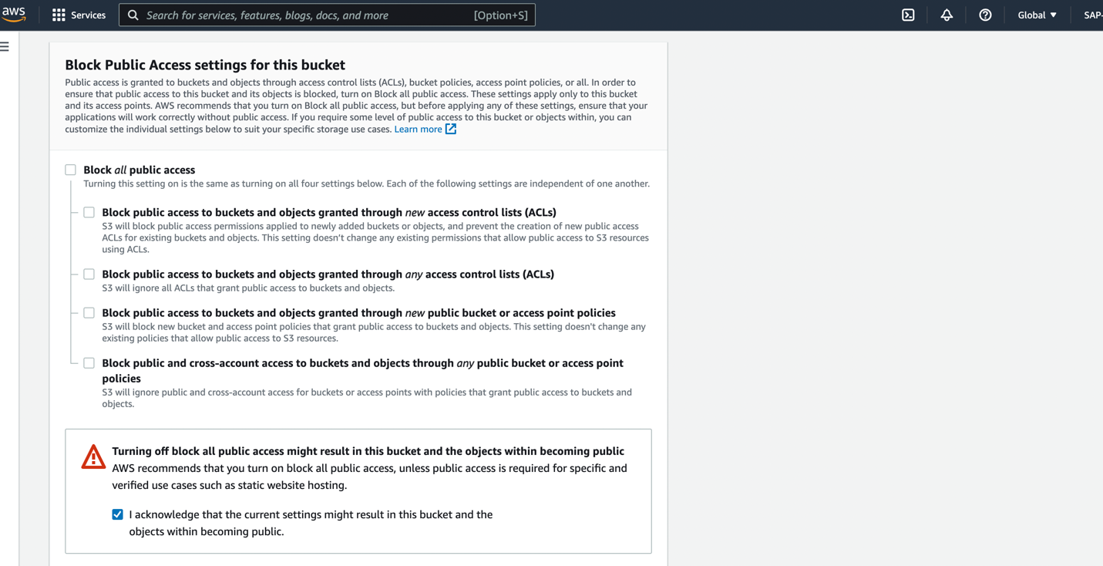

1. Bucket versioning:
   1. **Disable/Enable** – If ‘Enable’ is opt, new version will be saved of object modifications. By default, its disable. We kept it as ‘Disable’.
2. Tags Optional – we have given ‘Tag’ to check the services being created for specific module.
3. Default encryption
   1. **Enable/Disable** – We can enable server-side encryption, by default its disable. And we kept it as ‘Disable’.

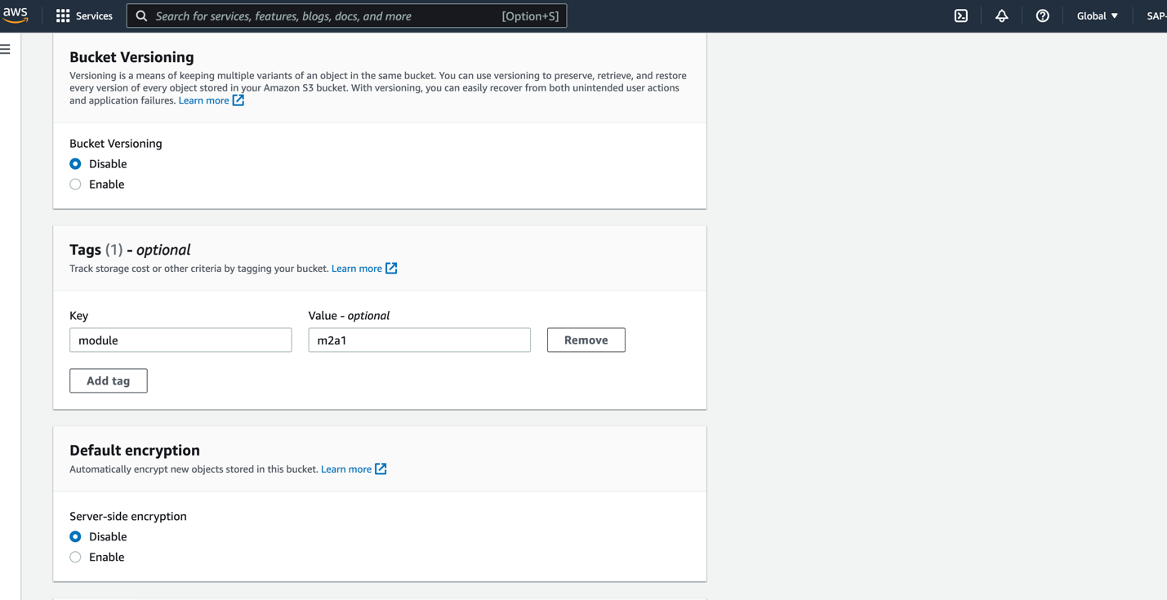

1. Advance settings
   1. **Object lock Enable/Disable** – by default its disable. To protect objects in this bucket from modification or deletion, we can choose enable. I kept this option as ‘Disable’.

Step 3: Click on. ‘Create bucket’

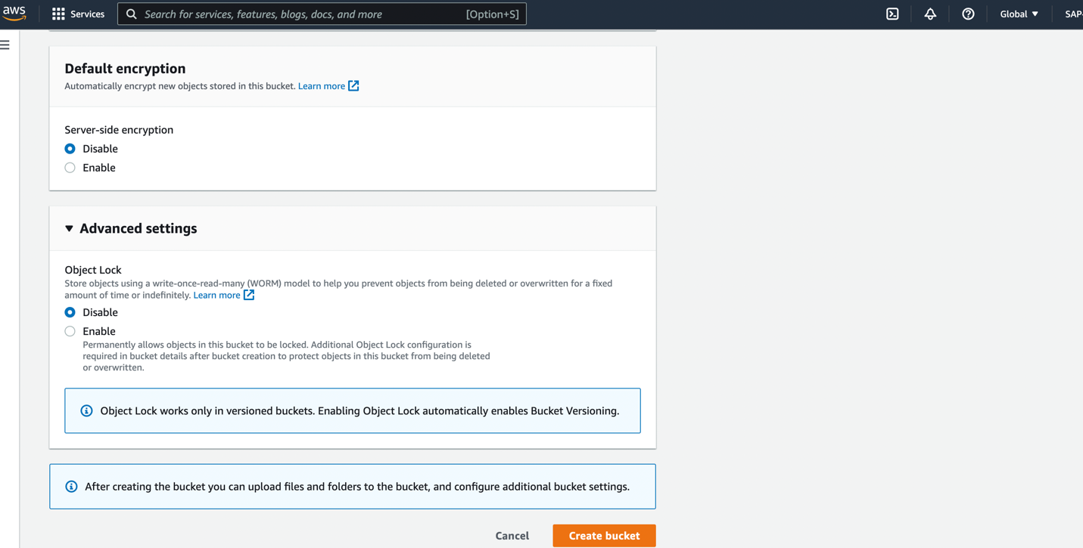

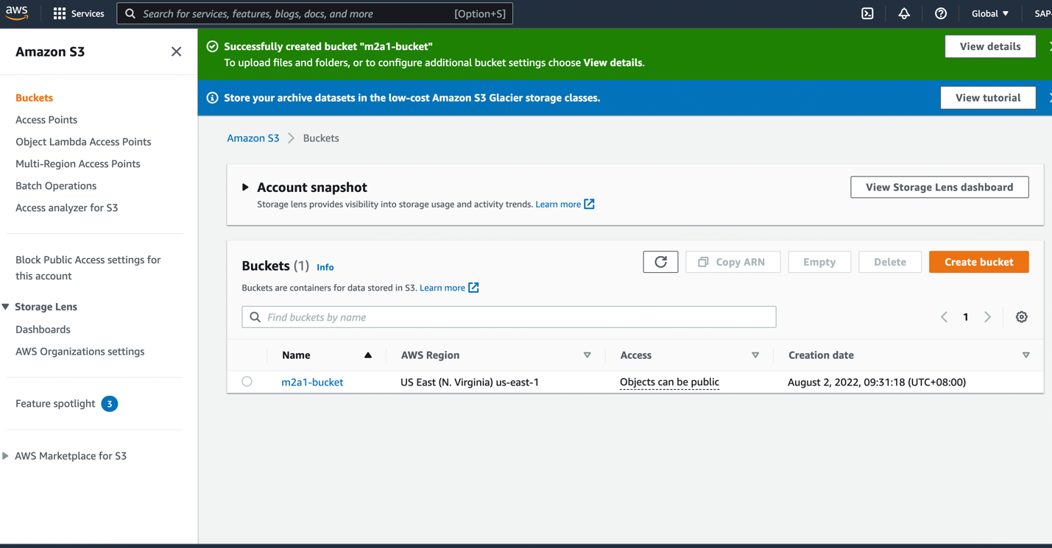

# **Task 1**- To upload object

Below are the steps performed to upload the object in the above created bucket ‘**m2a1-bucket**’.

1. Click on the bucket name ‘**m2a1-bucket’** from the bucket dashboard.
2. Click on ‘**Upload’** button.

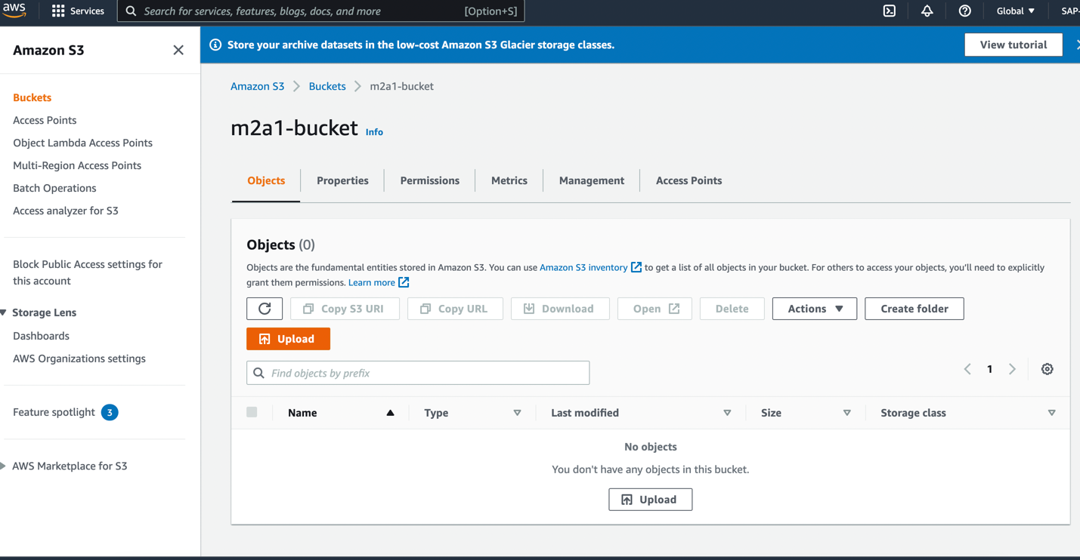

1. Click on ‘**Add file’** or ‘**Add folder’** and choose the file or folder from your system.

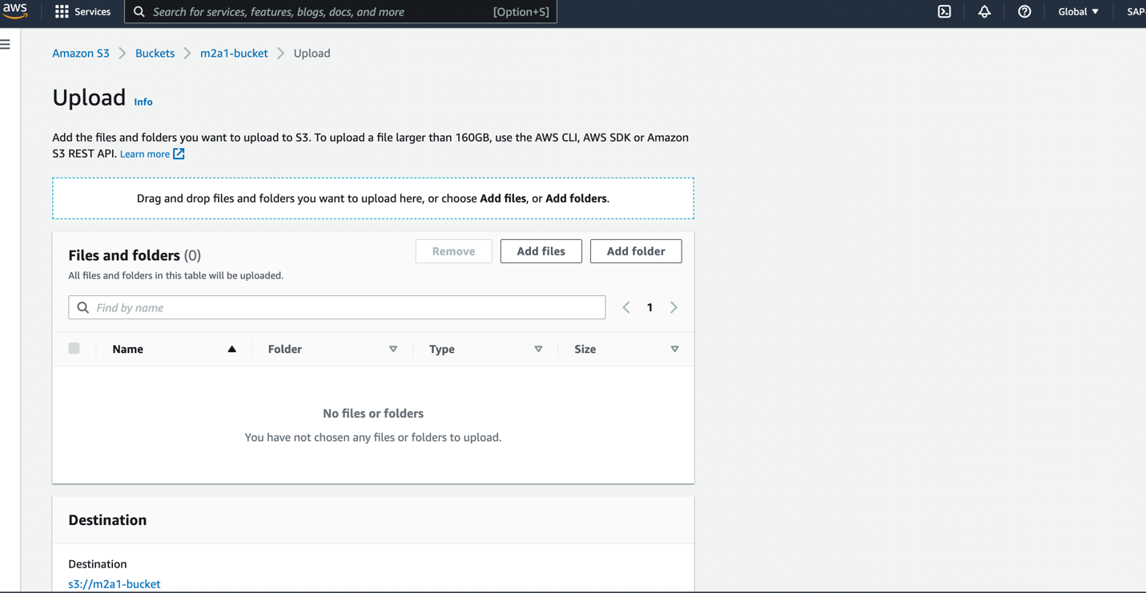

1. After upload we can see the filename ‘**Screen Shot…**’ in file and folder section.

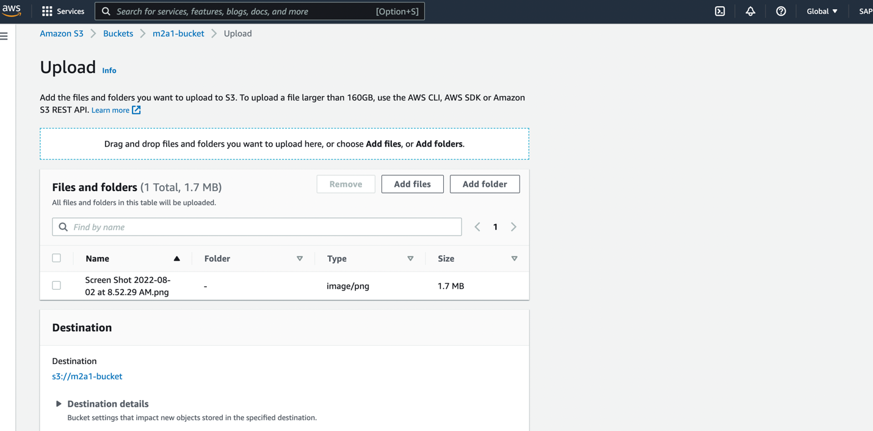

1. Destination Details - Policies and configuration set while bucket creation is enforced on objects, hence we can modify settings (Bucket versioning, encryption, object lock) on objects while uploading objects in bucket. I left these configuration as it is.
2. Permissions – Can modify the access permission. I kept the permission settings as it was while bucket creation.

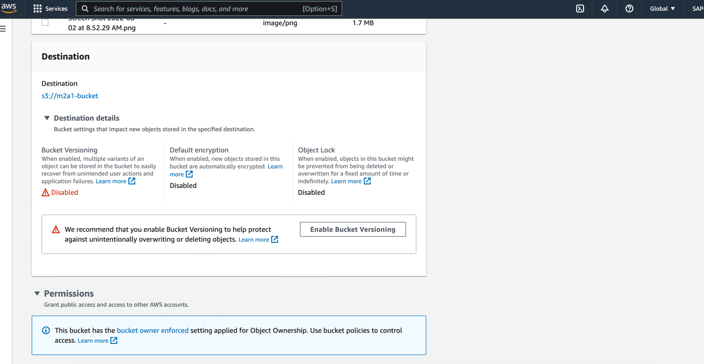

1. Properties – Can select the class of storage as per requirement, cost. By default, its Standard and it is available with >= 3 AZ. Kept it as Standard.

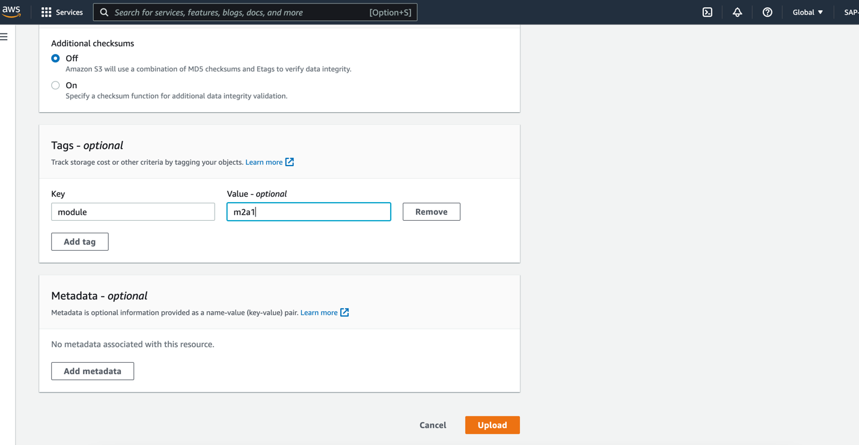

1. Tags and metadata – It can be used to give the tag to the object and details about the tag Key pair.
2. Click on ‘**Upload’.**

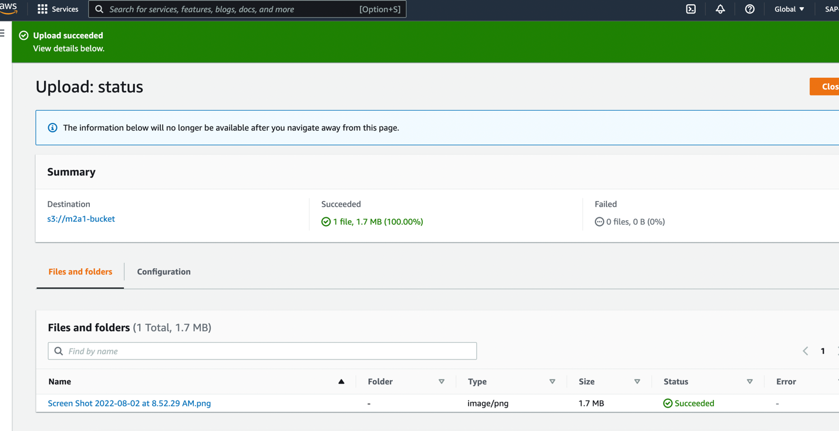

# Task 2 – To download the object

Below are the steps performed to download the object from the bucket ‘**m2a1-bucket**’:

1. Choose the bucket ‘**m2a1-bucket**’.

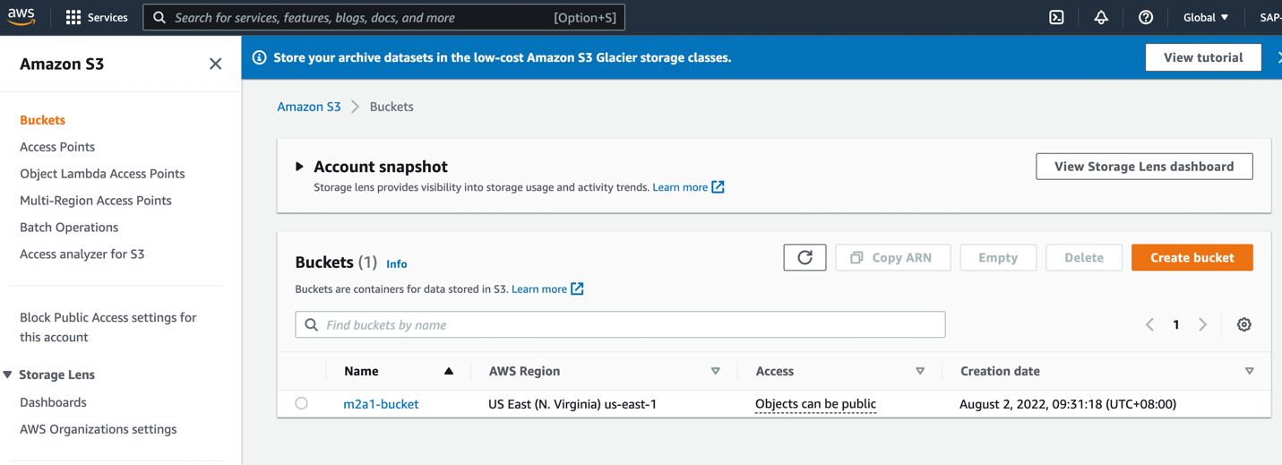

1. Select the object ‘**Screen Shot…**’ or click on the object name.

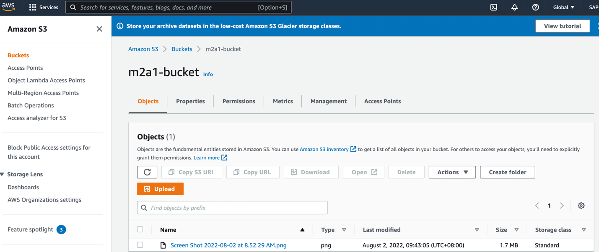

1. Click the ‘**Download’** button**.**

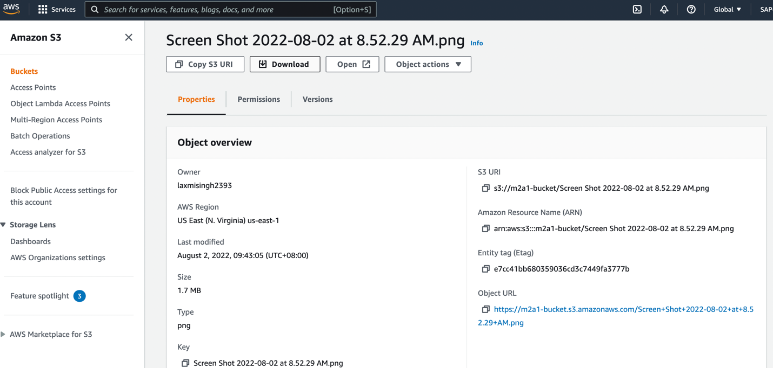

1. File will be stored on your system.

# Task 3 - Copy your object to a folder

Below are the steps performed to copy the object from the bucket ‘**m2a1-bucket**’ to a new folder:

1. Go inside the bucket
2. Create a folder by clicking on ‘**Create folder’**

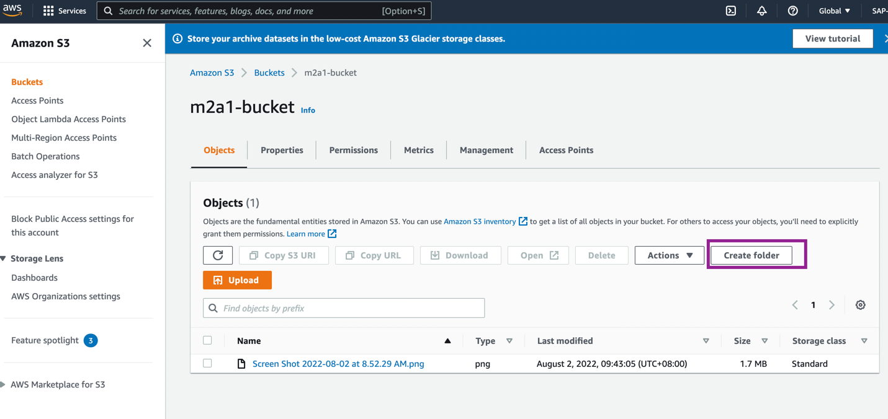

1. Write the name ‘folder- toCopyObject’ and click on ‘**Create folder’**

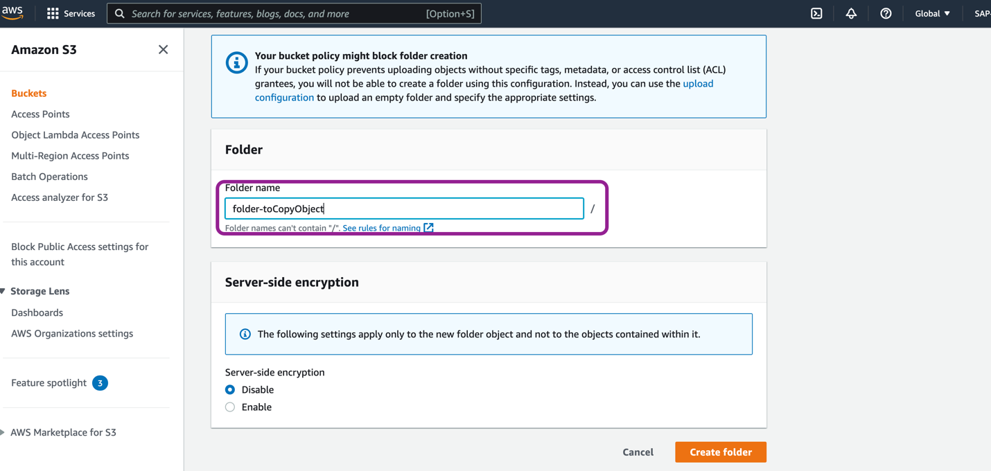

1. Created folder will be visible as per below image in bucket.

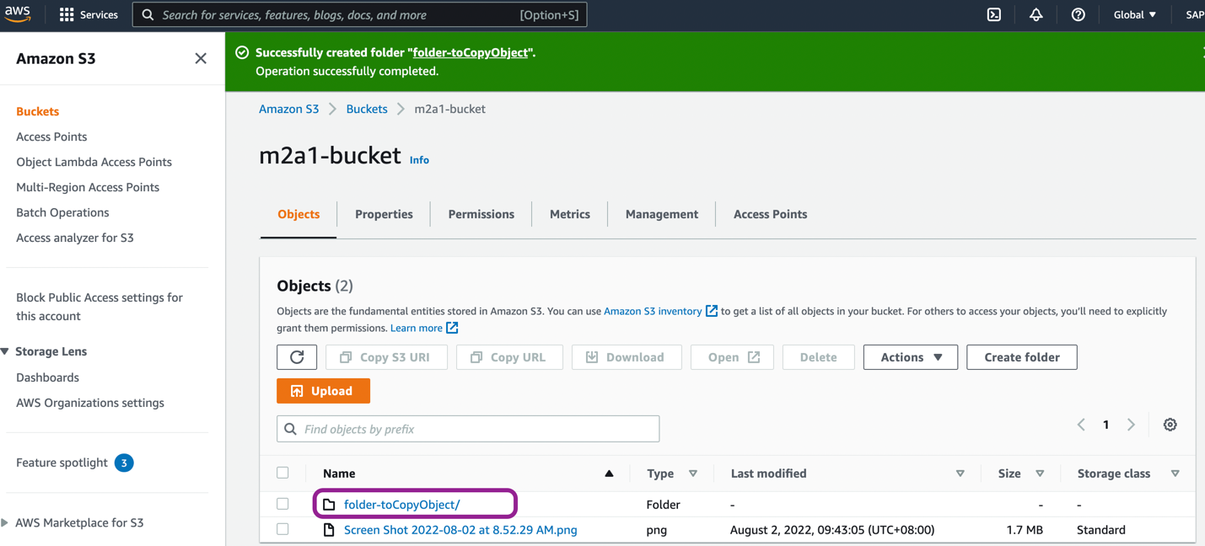

1. Select the object, to copy, click on ‘**Actions’** and then click on ‘**Copy’** from actions dropdown

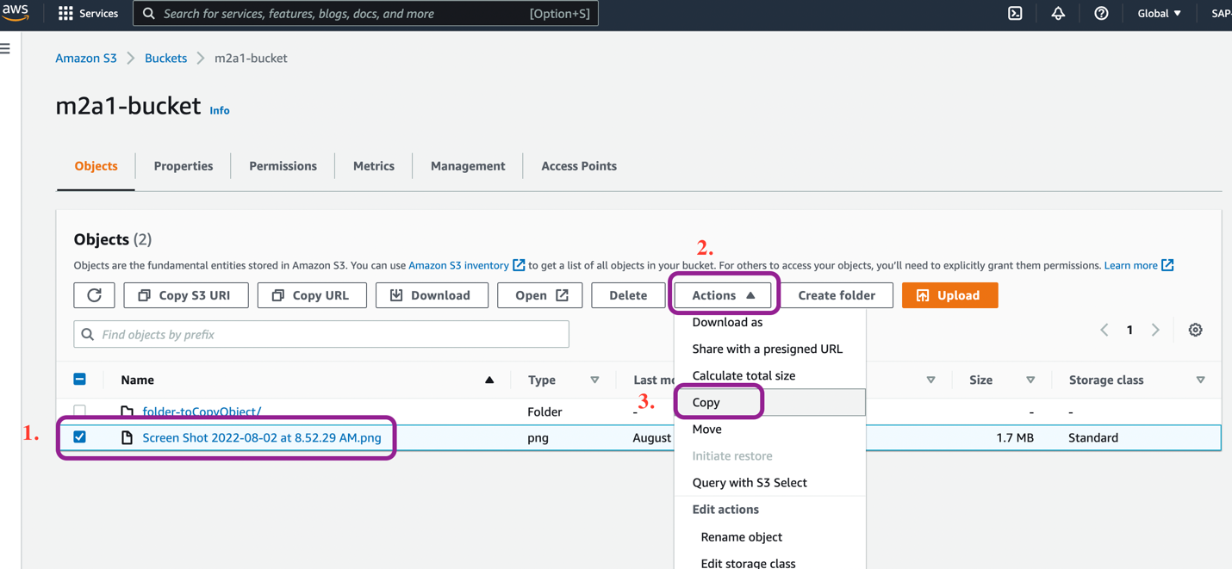

1. In Section of **Destination** choose Bucket (by default selected) under Destination type, click on **‘Browse s3’**, all the available files and folders will be available to choose from the bucket. Select the folder ‘folder-toCopyObject’, and click on **Choose Destination**.

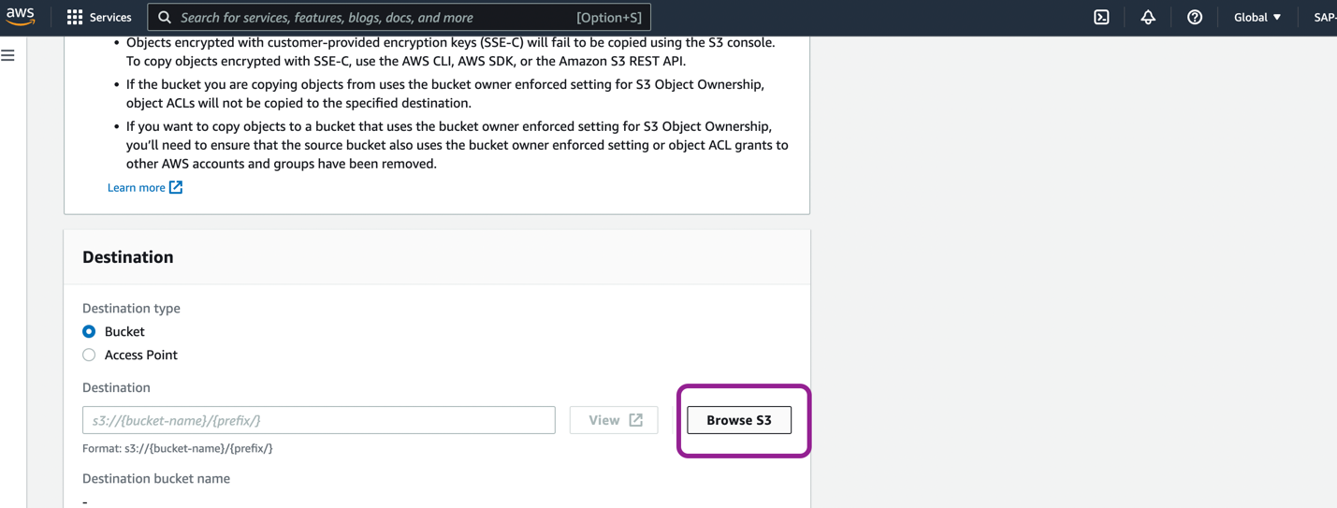

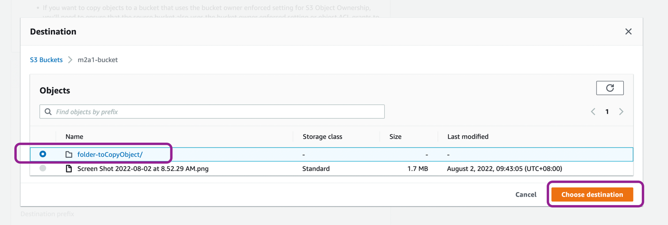

1. Now a path will be selected in Destination section

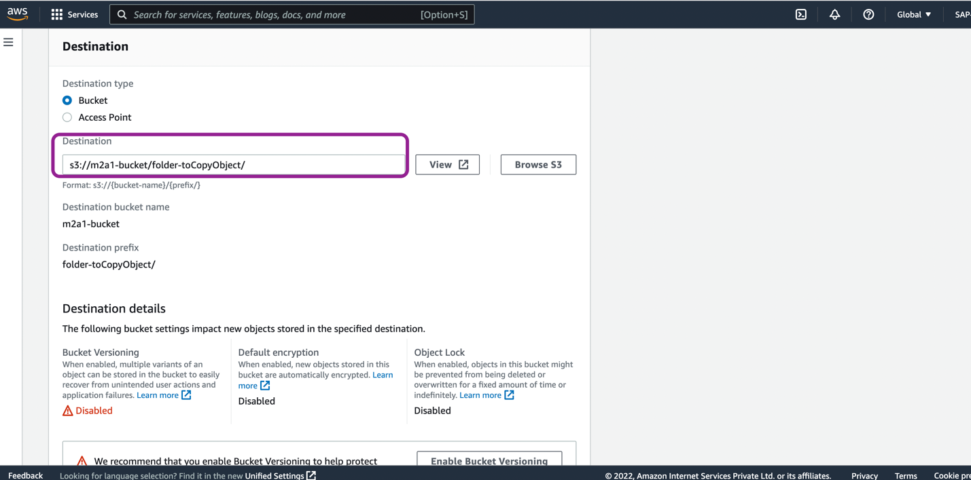

1. In specified object, check the object if we are copying correct object

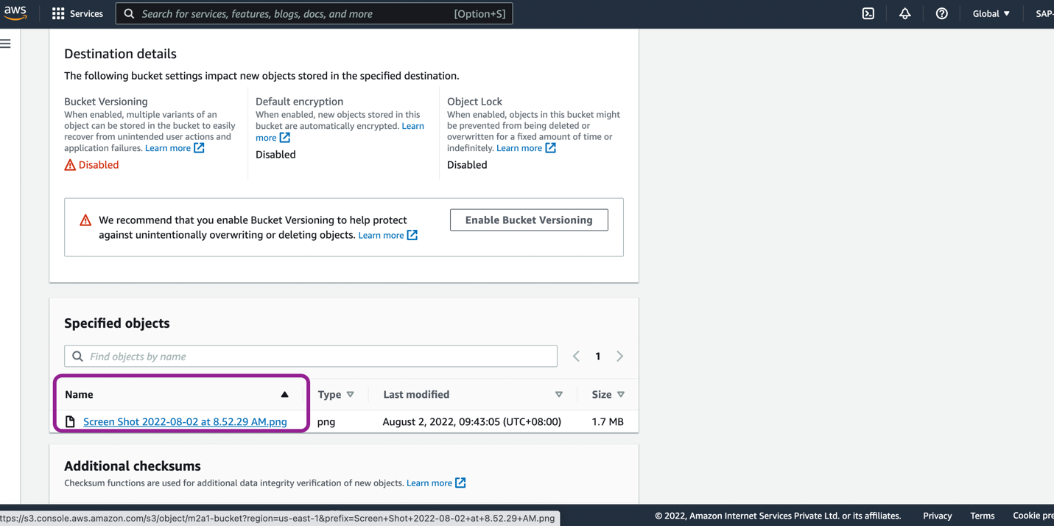

1. Click on **Copy**, upon success a message will be seen on screen with ‘Successfully copied object’ message.

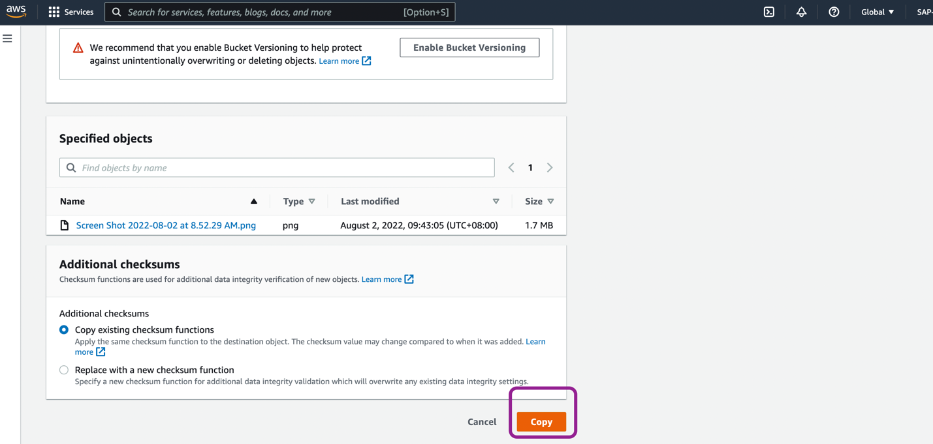

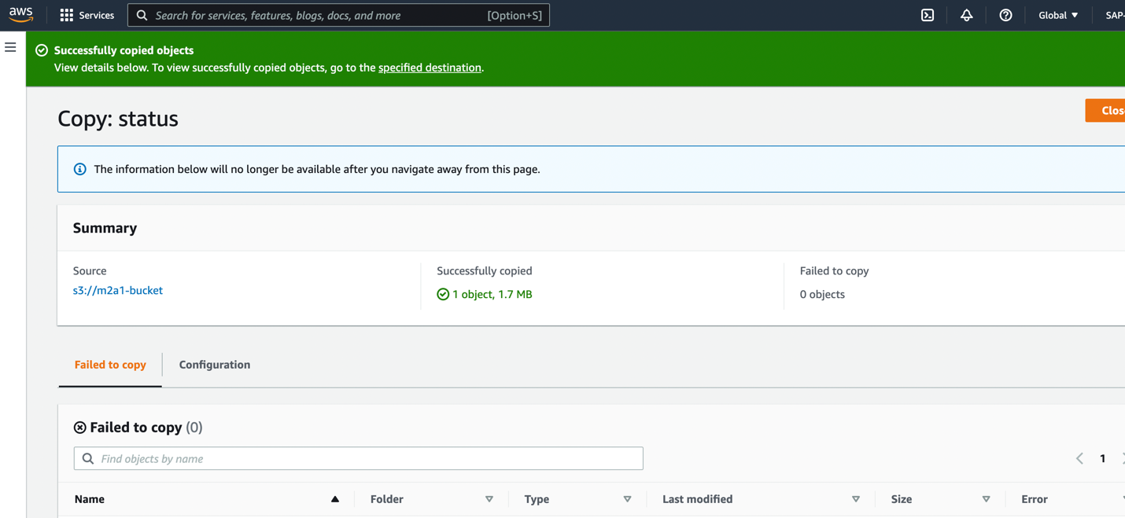

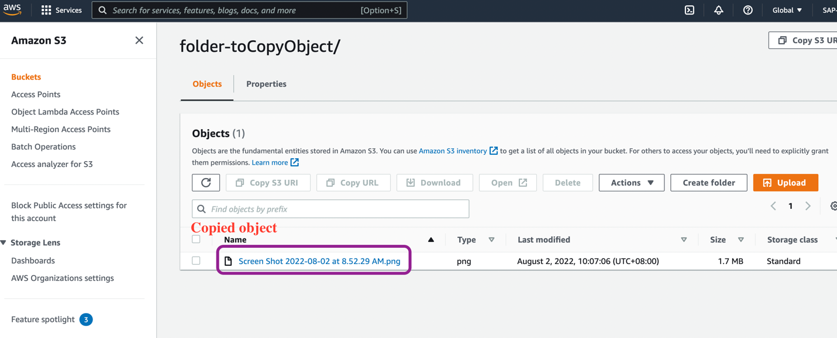

# Task 4 - Delete object and bucket

Below are the steps performed to delete object and the bucket ‘**m2a1-bucket**’:

1. To delete bucket, we first make the bucket empty
2. Select the bucket and click on empty

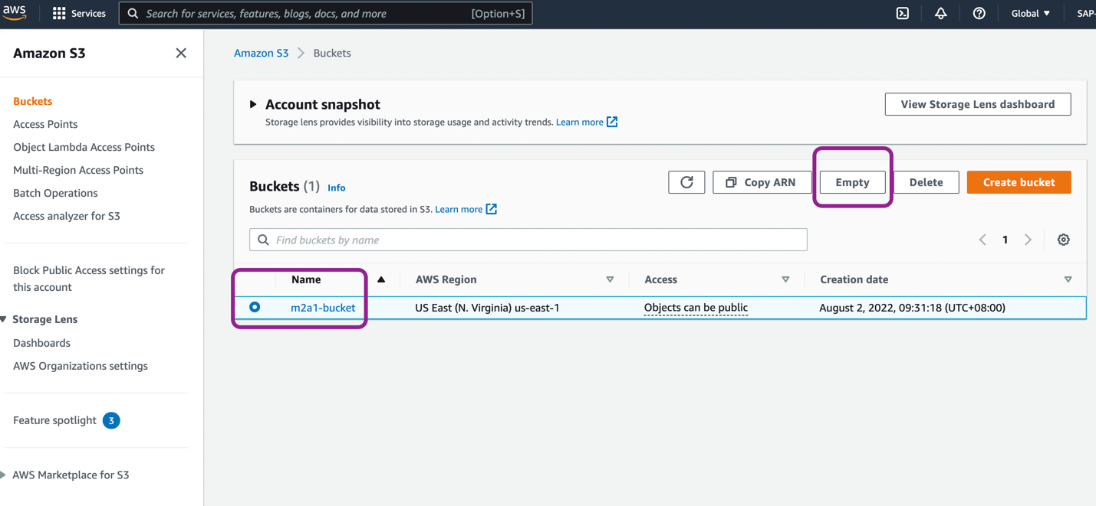

1. To confirm the deletion, type ‘**permanently delete’** and click on ‘**Empty’**

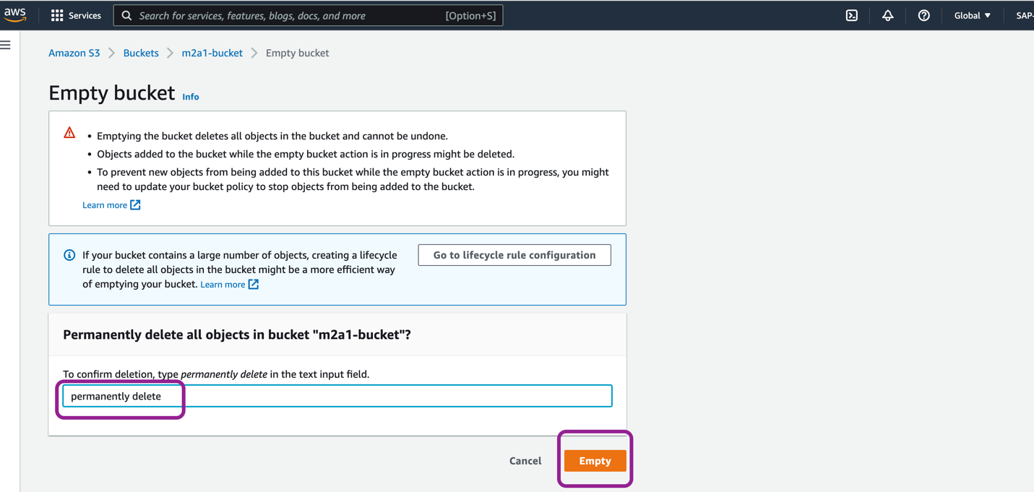

1. ‘Successfully emptied bucket ‘m2a1-bucket’’ message will prompt.

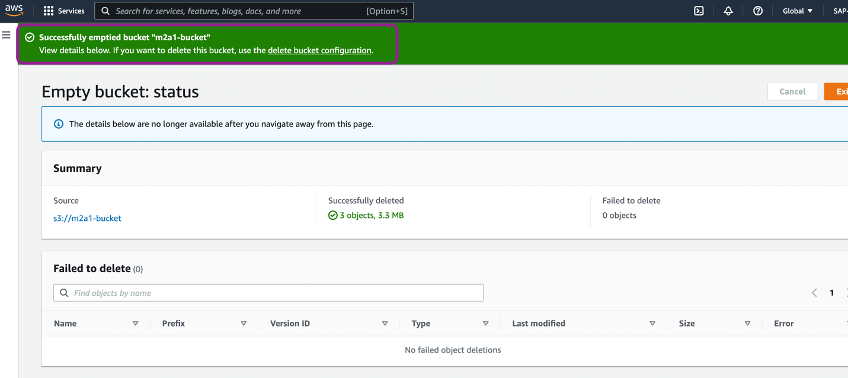

1. Select the bucket and click on **Delete**

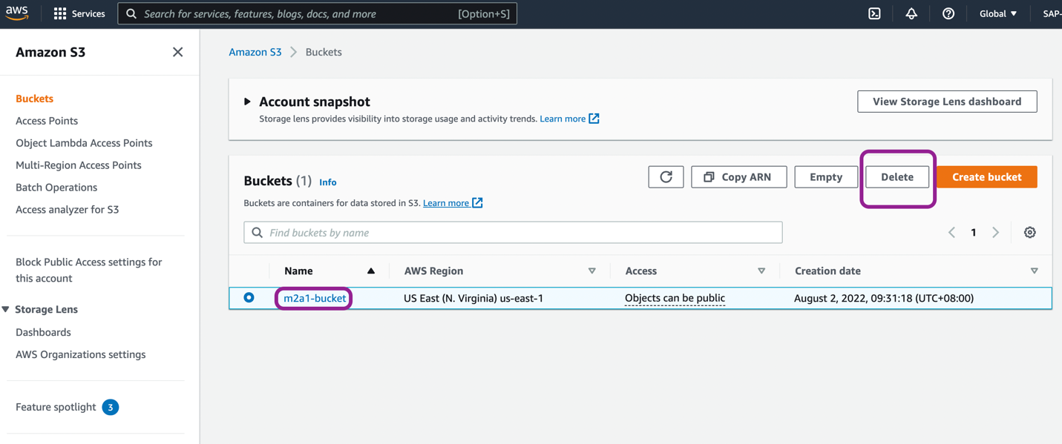

1. To confirm the deletion, type the bucket name in text box ‘m2a1-bucket’ and click on ‘**Delete bucket’**

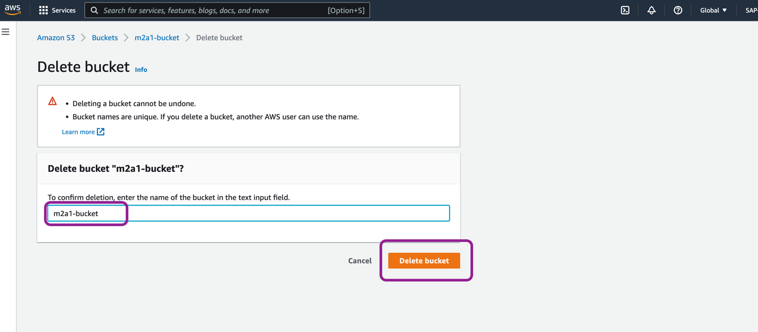

We will receive successful deletion message.

